Practical No 1
Name:Karuna Adhik Shejwal
Class: MCA I Div: Gamma

Study and implement of python installation, IDLE and Jupiter Notebook.
1.Python IDLE installation:
Step 1: Go to browser, Go to official python website.
https://www.python.org

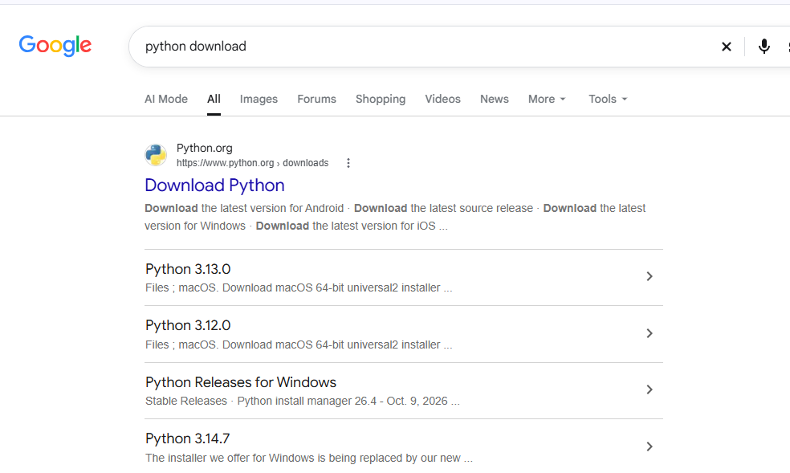

Step 2:Download IDLE from website.

https://www.python.org/downloads/
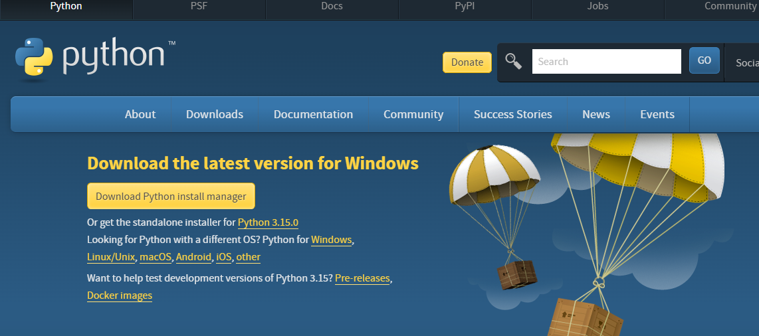

Step 3: select windows and download installer.
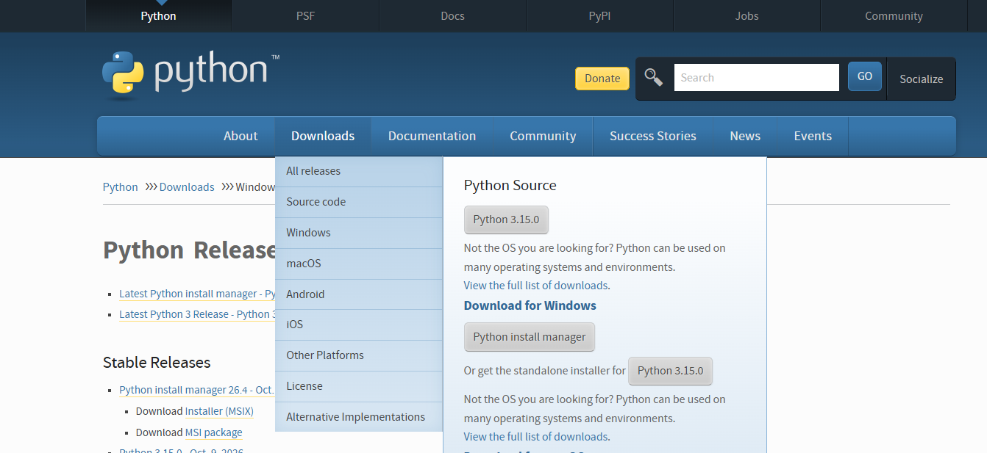
Step 4: verify python installation is complete:
Open command prompt:
- Press windows+R
- Type cmd
- Press enter
- Run command:
python –version
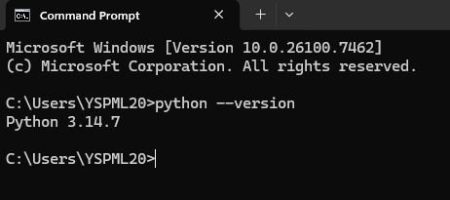

Step 5: open python IDLE:
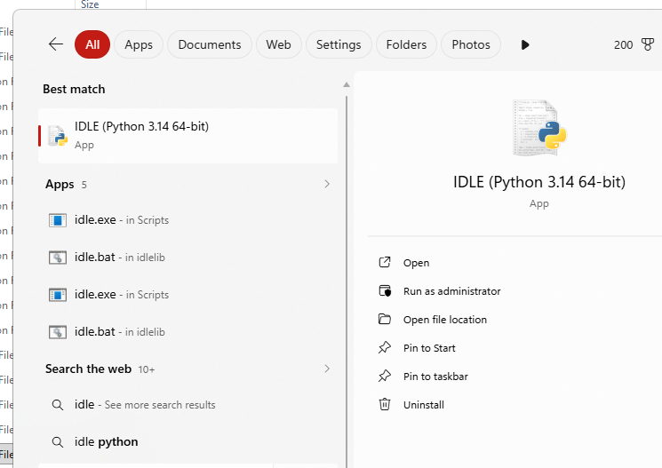

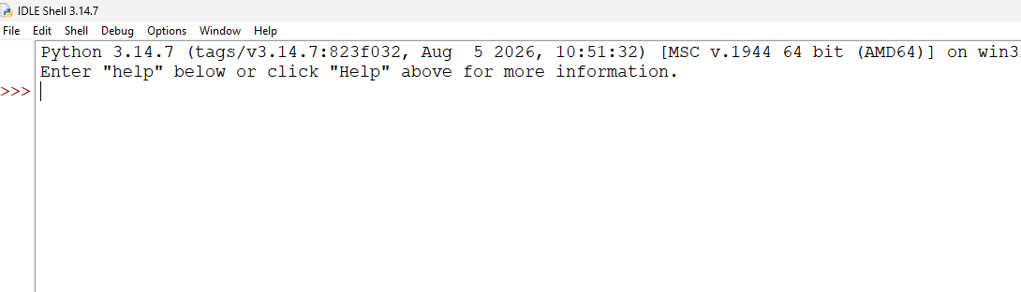

2.Jupiter Notebook Download:
Step 1: Go to command promt and check the pyrthon version.
Step 2: Download the Jupiter notebook and pas the command.
Python –m pip install notbook
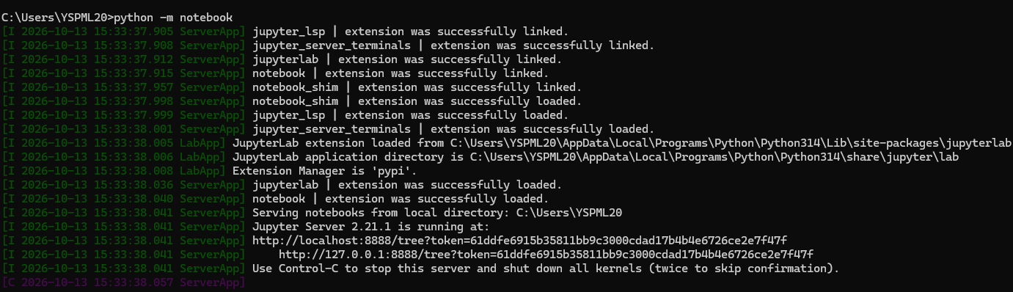

Step 3 :- Pass the command jupyter notebook will be open on browser.
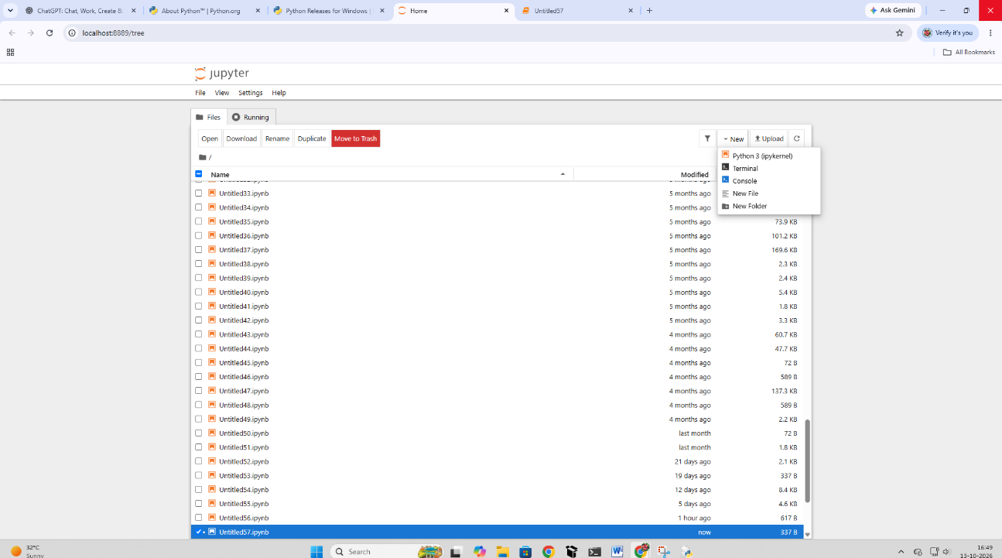
Step 4 :- After successfully installation of jupyter notebook create notebook create new file and select terminal
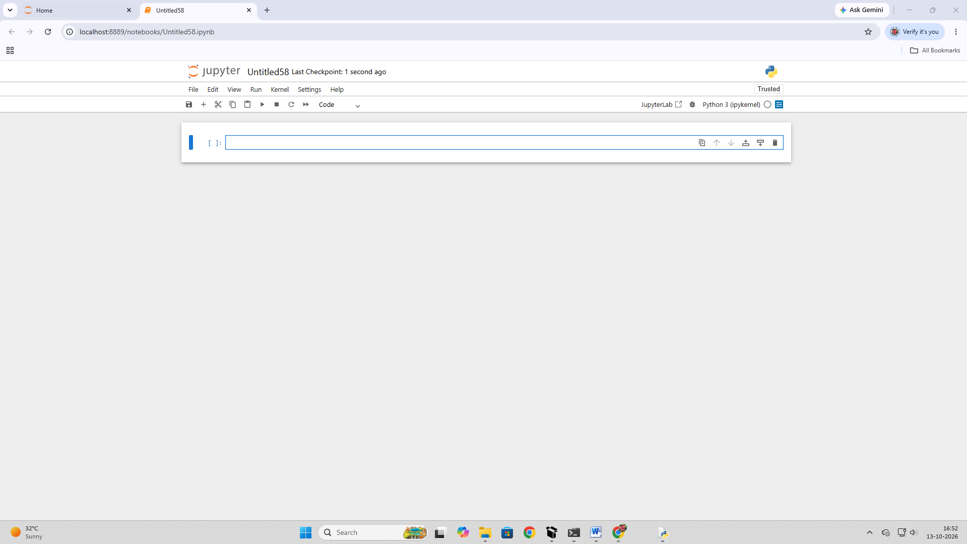

Practical No 2
Name:Karuna Adhik Shejwal
Class: MCA I Div: Gamma
Que. Write a python program to demonstrate variables , standard data type ,input / output ,type conversion and operators (arithmetic, relational, logical, assignment, membership, and identity).
- Variables and standard data type
name="karuna"
age=21
marks=95.5
print("name:",name)
print("age:",age)
output:
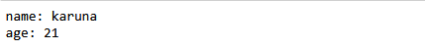
- Input/Output
a= int(input("enter first number: "))
b= int (input("enter seconmd number: "))
print ("first number:",a)
print("second number:",b)
output:
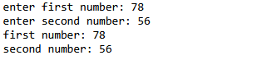

- Type Conversion
x="178"
y=
z=float(y)
print(type("after conversion :",y)
print("float value:",z)
output:
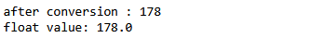
- Arithematic operator
a=10
b=20
print("addition:", a+b)
print("Substraction:", a-b)
print("Multiplication:", a*b)
print("Division:", a/b)
print("Modulus:", a%b)
output:
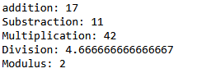

Practical No 3
Name:Karuna Adhik Shejwal
Class: MCA I Div: Gamma
Que. Write program to demonstrate decision making statement and looping constructs by finding the largest of three number, generating the Fibonacci series and calculating the factorial of a given number.
- Decision Making Statement
a=(input("enter first number"))
b=(input("enter second number"))
c=(input("enter thrid number"))
if a>=b and a>=c:
print("a is greater than or equal to b & c")
elif b>=a and b>=c:
print("b is greater than or equal to a & c")
else:
print("c is greater than or equal to a & b")
Output:
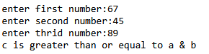

- Fibonacci Series
n=int(input ("enter a number of terms: "))
a=0
b=1
for i in range (n):
print(a,end=" ")
c=a+b
a=b
b=c

Output:
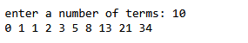

- Factorial Number
n=int(input("enter a number: "))
fact = 1
for i in range(1,n+1):
fact = fact*i
print(fact)
Output:
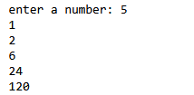

Practical No 4
Name:Karuna Adhik Shejwal
Class: MCA I Div: Gamma
Que. Write a python program to check whether a given number is prime ,Armstrong , or palindrome.
- Prime Number
n = int(input("Enter a number: "))

if n < 2:
print("Not Prime")
else:
for i in range(2, n):
if n % i == 0:
print("Not Prime")
break
else:
print("Prime")
Output:
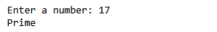

- Armstrong Number
n = int(input("Enter a number: "))
temp = n
sum = 0
digits = len(str(n))

while temp > 0:
digit = temp % 10
sum += digit ** digits
temp //= 10

if sum == n:
print("Armstrong Number")
else:
print("Not an Armstrong Number")
Output:
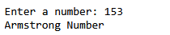

3. Palindrome Number
n = int(input("Enter a number: "))
temp = n
rev = 0

while temp > 0:
digit = temp % 10
rev = rev * 10 + digit
temp = temp // 10

if n == rev:
print("Palindrome Number")
else:
print("Not a Palindrome Number")
Output:


Practical No 5
Name:Karuna Adhik shejwal
Class: MCA I Div: Gamma
Que. Write a program python to perform operation on standard data types include list, tuple, set and dictionary(creation, insertion, deletion, searching, updating and traversal).
1. List
A. Create list
list1=[1,2,3,4,5]
print(list1)
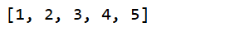
B. Concatinate list to create a new list
list1=[1,2,3,4,5]
list2=[6,7,8,9,10]
list3=list1+list2
print(list3)

C. Update list
a=[1,2,3,4,5]
a[1]=25
print(a)
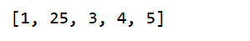
D. Delete element to the list
a=[1,2,3,4,5]
a.remove(4)
print(a)
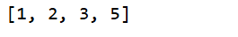

2. Tuple
A. Create Tuple
a=(1,2,3,4,5)
print(a)
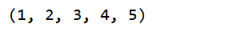
B. Insert Element

3.Set
A. Create Set
a={1,2,3,4,5}
print(a)
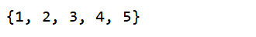
B. Insert Element
a={1,2,3,4,5}
print(a)
a.add(6)
print(a)
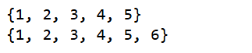
C. Delete Element to the Set
a={1,2,3,4,5}
print(a)
a.remove(3)
print(a)
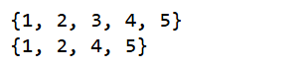

D. Update Element to the Set
a={1,2,3,4,5}
b={6,7,8}
a.update(b)
print(a)
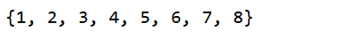

4.Dictionary:
A. Create dictionary
dic1={"name":"karuna","age":21,"address":"satara","email":"karuna@gmail.com"}
dic1["course"]="MCA"
print(dic1)
Output:

B. Concatinate dictionary to create a new dictionary
dic1={"name":"karuna","age":21,"address":"pali"}
dic2={"email":"karuna@gmail.com",'course': 'MCA'}
dic1.update(dic2)
print(dic1)
Output:”

C .Check if a given key alredy exit in a dictionary
dic1={"name":"shivani","age":21,"address":"satara","email":"abc@gmail.com"}
print("name" in dic1)
Output:
D .Remove a key from a dictionary
dic1={"name":"shivani","age":21,"address":"satara","email":"abc@gmail.com",'course': 'MCA'}
dic1.pop("course")
print(dic1)
Output:
E. print a dictionary line by line
dic1={"name":"shivani","age":21,"address":"satara","email":"abc@gmail.com",'course': 'MCA'}
for i,j in dic1.items():
print (i ,":",j)
Output:

Practical No 6
Name:Karuna Adhik Shejwal
Class: MCA I Div: Gamma
Que. Write a python program to perfrom string operations.

